Hockey Canada
High Performance 1
Teaching Techniques in Coaching:
Additional Coaching Resource Material
Version 1.0

The Collection, Use, and Disclosure of Personal Information
The Coaching Association of Canada collects your NCCP qualifications and personal information and shares it with all NCCP partners according to the privacy policy detailed at www.coach.ca. By participating in the NCCP you are providing consent for your information to be gathered and shared as detailed in the privacy policy. If you have any questions or would like to abstain from participating in the NCCP please contact coach@coach.ca.

The influence of a teacher will last for an eternity, you never know when it starts or stops.
(Tuesdays with Morrie)

The Best Teacher I Ever Had
by Chris Novak

Mrs. Thompson taught 5th grade and like to thing of herself as a very good teacher who treated all her students the same – that is, until a frumpy little boy name, Teddy Stoddard, sat slumped in a front row seat one year and change everything.
Mrs. Thompson had watched Teddy the year before and noticed that he didn’t play well with the other children, that his clothes were messy, that he constantly needed a bath, and that in fact, Teddy could be very unpleasant. It got to the point where Mrs. Thompson would actually take delight in marking his papers with a broad red pen, making bold X’s and them putting a big “F” at the top of his papers.
All that changed though when Mrs. Thompson finally got around to reviewing Teddy’s school records.
Teddy’s first grade teacher wrote, “Teddy is a bright child with a ready laugh. He does his work neatly and has good manners…he is a joy to be around.” His second grade teacher wrote, “Teddy is an excellent student, well liked by his classmates, but he is troubled because his mother has a terminal illness and life at home must be a struggle.”
His third grade teacher wrote, “His mother’s death has been hard on him. He tries to do his best, but his father doesn’t show much interest and his home life will soon affect him if some steps aren’t taken.” Teddy’s fourth grade teacher wrote, “Teddy is withdrawn and doesn’t show much interest in school. He doesn’t have many friends and sometimes sleeps in class.”
Mrs. Thompson realized that Teddy was not a problem child at all but a child whose problems had overwhelmed him. She was ashamed of herself for he haste to judge the struggling boy. She felt even worse when her students brought her Christmas presents that year, wrapped in beautiful paper and tied with pretty ribbons, except for Teddy’s whose present was clumsily wrapped in the heavy brown paper the he got from a grocery bag.
Opening Teddy’s gift, she extracted a rhinestone bracelet with some of the stones missing, and a bottle that was one quarter full of perfume. The other children erupted in laughter but she stifled them with an exclamation of how pretty the bracelet was as she put it on, dabbing some of the perfume on her wrist too. Teddy Stoddard stayed after school that day just long enough to say, “Mrs. Thompson, today you smelled just like my mom used to.”
Mrs. Thompson went back to her room, closed the door and cried for an hour. When she composed herself, she vowed to quit teaching reading, and writing, and arithmetic and start teaching children – starting with Teddy. As she worked with him, his mind seemed to come alive. The more she encouraged him, the faster he responded. By the end of the year, Teddy had become one of the smartest children in the class and one of her favorites.
About a year later, Mrs. Thompson walked into her classroom and found a note from Teddy slid under her door. It said that she was still the best teacher he ever had in his whole life. Six year would go by before she go another note from Teddy who wrote that he had finished high school, third in his class, and she was still the best teacher he ever had in his whole life. Four years after that, she got another letter, saying that while things had been tough at times, he’d stayed in school, had stuck with it and would soon graduate from college with the highest of honors. He assured Mrs. Thompson that she was still the best and favorite teacher he ever had in his whole life.
Four more years passed and yet another letter came explaining that after he got his bachelor’s degree, he decided to go a little further. The letter said that she was still the best and favorite teach he ever had but that now his name was a little longer – the letter was signed, Theodore F. Stoddard, MD.
Later that same spring, there was yet another letter from Teddy saying he was going to be married. He explained that his father had died a couple of years ago and he was wondering if Mrs. Thompson might agree to sit in the place at the wedding that was usually reserved for the mother of the groom.
Mrs. Thompson arrived at the ceremony wearing the bracelet with several rhinestones missing that Teddy had given her so many year before and the perfume that Teddy remembered his mother wearing on their last Christmas together.
They hugged each other, and Dr. Stoddard whispered, “Thank you Mrs. Thompson for believing in me. Thank you so much for making me feel important and showing me that I could make a difference.”
Mrs. Thompson, with tears in her eyes, whispered back, “Teddy, you have it all wrong. You were the one who taught me that I could make a difference. I didn’t know how to teach until I met you.”

Characteristics of Successful Coaches

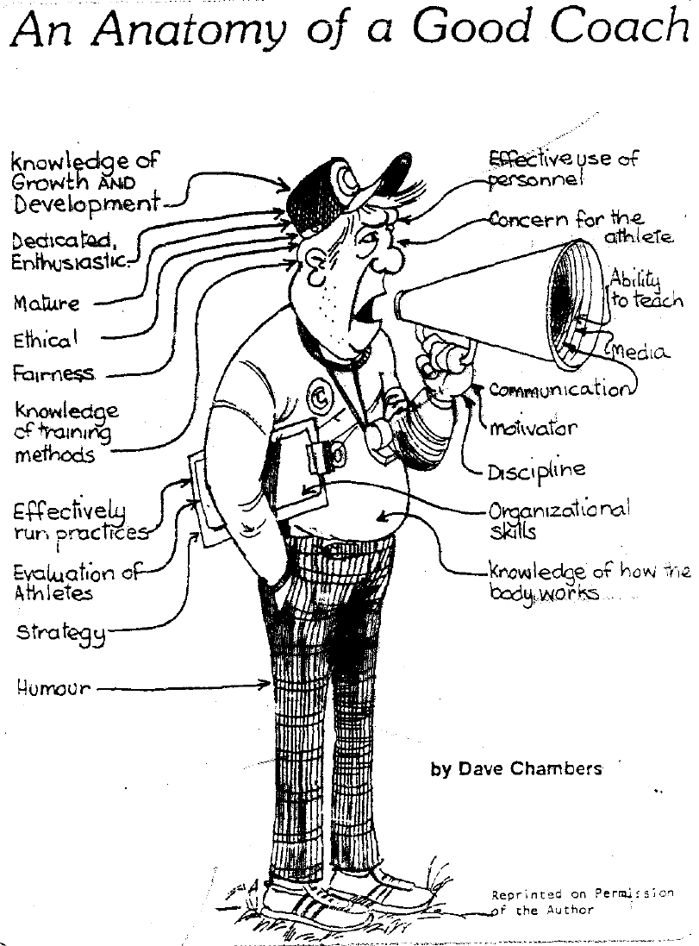

Teaching Characteristics

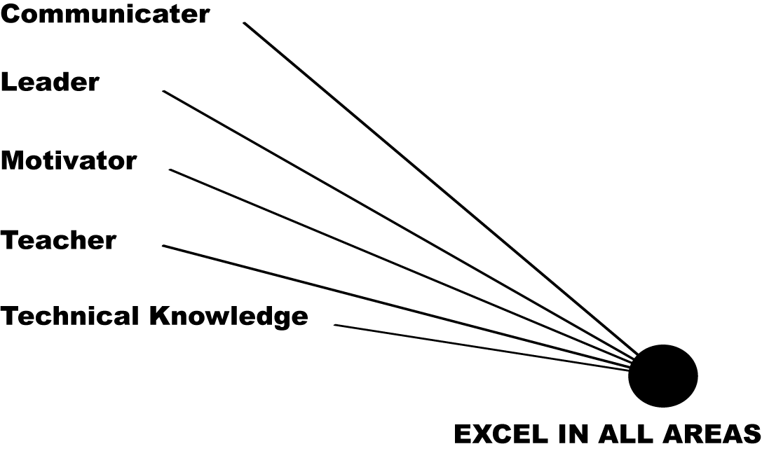
Manning 1989

Teaching Characteristics

Skill
A repeatable mental or physical action having an underlying procedure that when applied to similar contexts produces a consistent product.

Skills are described as:

OPEN or CLOSED
Performance is dependent on multiple factors. Controlled, limited factors.

BODY STABILITY or TRANSPORT
Skills performed in stationary position. Skills performed in moving position.

SELF-PACED or EXTERNALLY BASED
Controlled by the performer. Controlled by the opposition. Read and react.

SELF-MANIPULATION or MANIPULATION
No objects. Requires the manipulation of objects.

The Learning Process #1
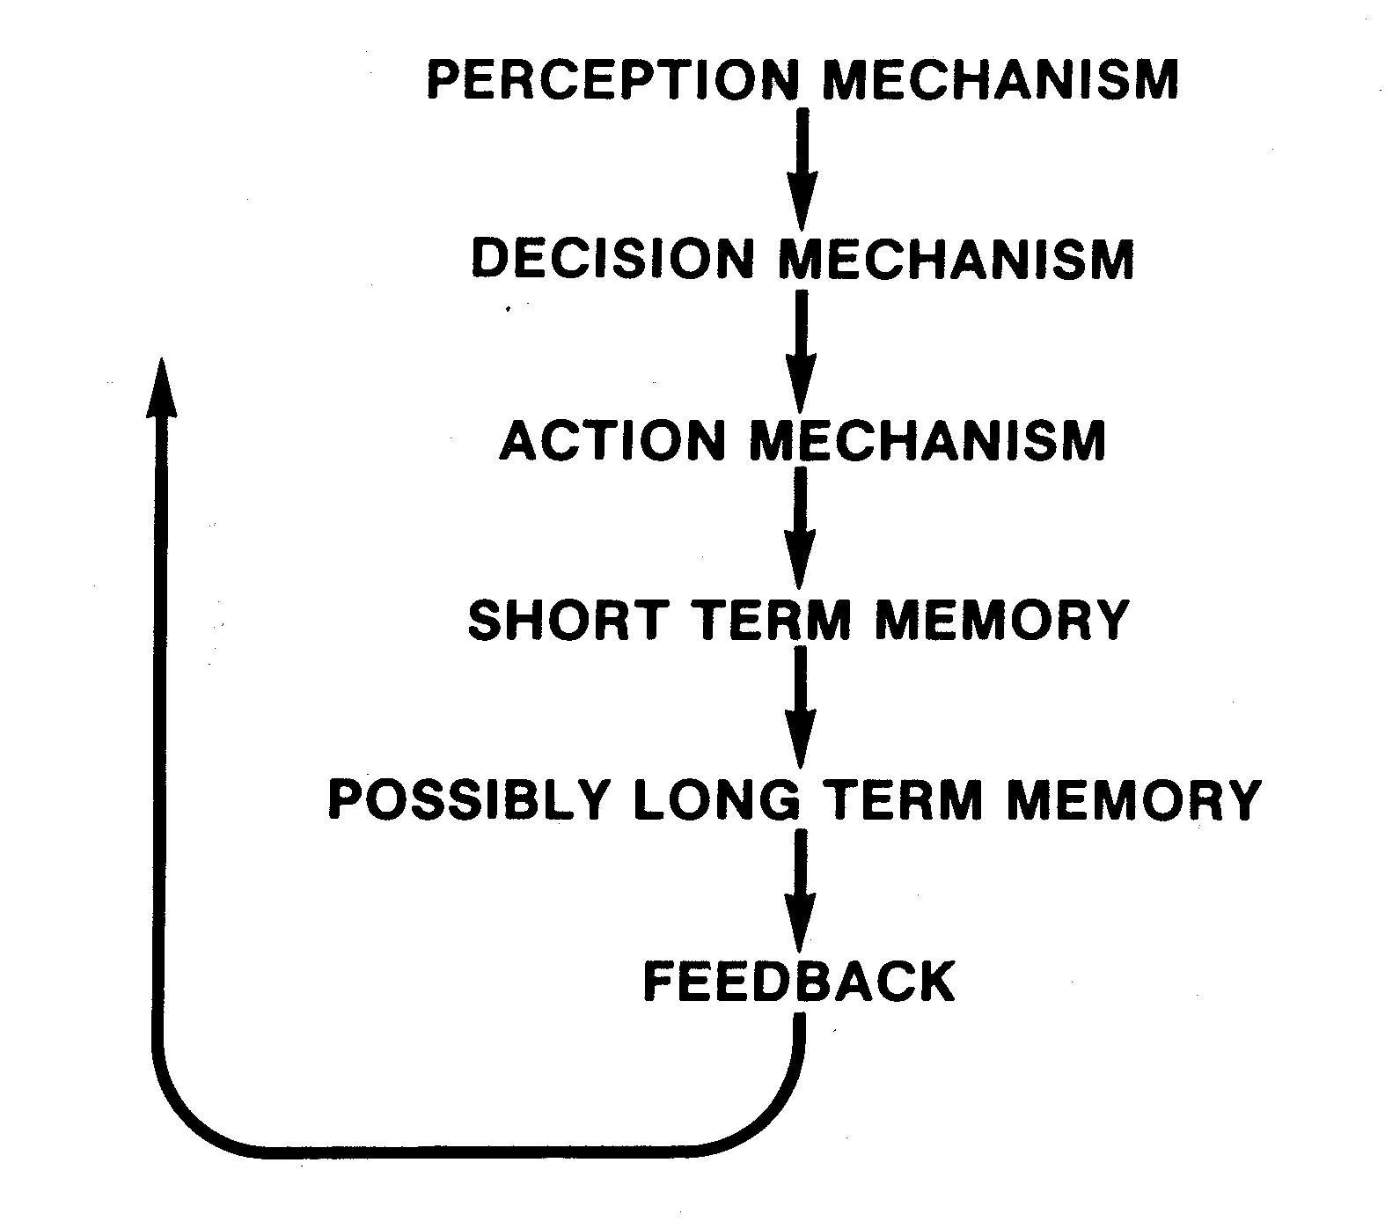

“In Teaching it is the method and not the context that is the message… the drawing out, not the pumping in.”
Ashley Montago

Specificity
Specificity is the ultimate quality in a perfect practice to develop perceptual motor skills in the game of hockey.

Reaction time is developed through the application of specificity in practice drills.

Drills
In preparing drills:
- What is the goal of the drill?
- What competitive situation am I trying to reproduce?
- How do I go about reproducing the situation with the greatest possible accuracy?
- How am I teaching the player to recognize and respond to this situation?
- What techniques am I teaching the player?
- Am I completely confident that the technique is the one best suited to the specific abilities of the player?

WOODEN’S EIGHT LAWS OF LEARNING
- Explanation
- Demonstration
- Imitation
- Repetition
- Repetition
- Repetition
- Repetition
- Repetition

“It is the supreme art of inspired teaching that awakens the joy of learning.”
Albert Einstein
Practice does not make perfect, perfect practice makes perfect.”
Nate St. Pierre

